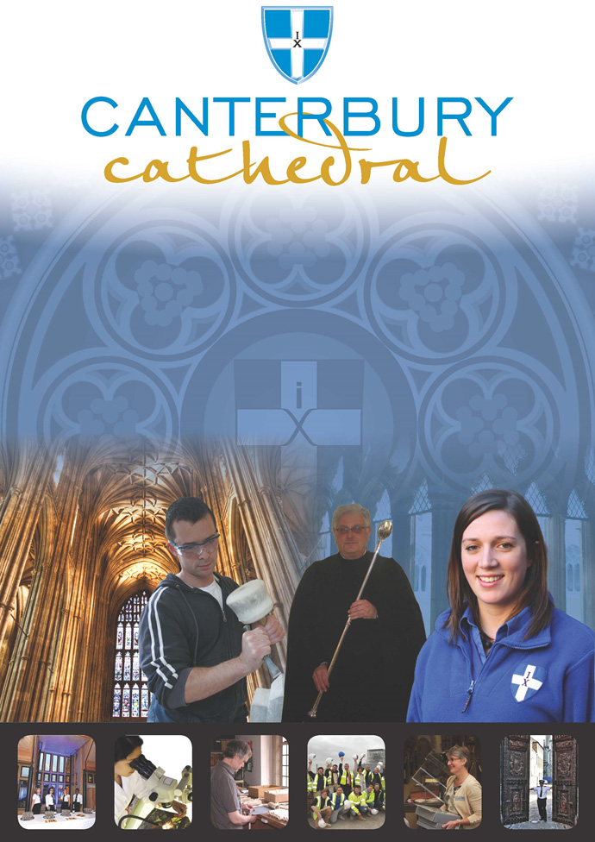

PROFILE OF CANTERBURY CATHEDRAL
St Augustine, the first Archbishop of Canterbury, arrived on the coast of Kent as a missionary to England in 597 AD. He came from Rome, sent by Pope Gregory the Great. It is said that Gregory had been struck by the beauty of Angle slaves he saw for sale in the city market and dispatched Augustine and some monks to convert them to Christianity. Augustine was given a church at Canterbury (St Martin’s, after St Martin of Tours, still standing today) by the local King, Ethelbert whose Queen, Bertha, a French Princess, was already a Christian. This building had been a place of worship during the Roman occupation of Britain and is the oldest church in England still in use. Augustine had been consecrated a bishop in France and was later made an archbishop by the Pope. He established his seat within the Roman city walls (the word cathedral is derived from the Latin word for a chair ‘cathedra’, which is itself taken from the Greek ‘kathedra’ meaning seat.) and built the first cathedral there, becoming the first Archbishop of Canterbury. Since that time, there has been a community around the Cathedral offering daily prayer to God; this community is arguably the oldest organisation in the English speaking world. The present Archbishop, The Most Revd Justin Welby, is 105th in the line of succession from Augustine.
Augustine’s original building lies beneath the floor of the nave– it was extensively rebuilt and enlarged by the Saxons, and the Cathedral was rebuilt completely by the Normans in 1070 following a major fire. There have been many additions to the building over the last nine hundred years, but parts of the quire and some of the windows and their stained glass date from the 12th century.
By 1077, Archbishop Lanfranc had rebuilt it as a Norman church, described as “nearly perfect”. A staircase and parts of the North Wall – in the area of the North West transept also called the Martyrdom – remain from that building.
During the Second World War, the Precincts were heavily damaged by enemy action and the Cathedral’s Library was destroyed. Thankfully, the Cathedral itself was not seriously harmed, due to the bravery of the team of fire watchers, who patrolled the roofs and dealt with the incendiary bombs dropped by enemy bombers.
Today, the Cathedral stands as a place where prayer to God has been offered daily for over 1,400 years; nearly 2,000 services are held each year, as well as countless private prayers from individuals. The Cathedral offers a warm welcome to all visitors – its aim is to show people Jesus, which we do through the splendour of the building as well as the beauty of the worship.

THE WORK OF THE CATHEDRAL
The work of the Cathedral is carried out by over 300 paid staff, supported by some 500 volunteers. The ‘corporate body’ responsible for the management of the Cathedral is the Chapter of Canterbury who are advised by the Cathedral Council and the College of Canons.

The Chapter of Canterbury (Chapter)
The Chapter are responsible for all aspects of the day-to-day management of the Cathedral. Chapter comprises the Dean, the Residentiary Canons, the Receiver General and four additional persons appointed by the Archbishop.

The Cathedral Council
The Council represents the Cathedral community as well as the wider local and regional community. It has 20 members, drawn from a wide variety of organisations. Its duty is to further and support the work of the Cathedral Church in spiritual, pastoral, evangelistic, social and ecumenical areas.

The College of Canons
The College of Canons is composed of 30 Honorary, Lay and Provincial Canons, appointed by the Archbishop and it supports the life of the Cathedral in many different ways.

The Cathedral Trust
The Cathedral Trust is a separate charity that is solely for the benefit of the Cathedral. Since 1974, it has assisted with the restoration, maintenance and improvement of the fabric and contents of Canterbury Cathedral and the provision, promotion and encouragement of music
The Cathedral is well-known all over the world and we welcome more than 1 million visitors and worshippers every year. The Cathedral is more than just a beautiful old building and heritage site; it is a working, living church which maintains a tradition of welcome and worship that has been practiced here for over 1400 years.

Friends
The Friends of Canterbury Cathedral was founded in 1927 by the distinguished scholar and poet Dean George Allen Kennedy Bell. The Organisation was the first of its kind in the world.
The Friends are the Cathedral’s fan club. Admirers of the building, its history and its community, Friends are a part of the Cathedral and work together to preserve it forever, contributing financially - and directly – to many individual and vital projects.

The Cathedral Shop
The Canterbury Cathedral Shop is a large gift shop in the heart of the city of Canterbury. It has an impressive range of high quality gifts, mostly British, and their own exclusive award winning designs.
The Shops wide range of merchandise includes replica historical artefacts, books and CD’s of the world-famous Canterbury Cathedral choir.

ROLE PROFILE
To provide direct practical and administrative support to the Music & Liturgy team, working on a range of projects and tasks as required.

Purpose/ summary of role

The Volunteer(s) will support the work of the Music & Liturgy department in their regular duties and with preparations for two events of international significance in 2020:
- Becket2020 (the 800th Anniversary of the consecration of Becket’s shrine in the Cathedral, and the 850th Anniversary of his Martydom) and
- Lambeth2020 (the conference of all the Bishops in the worldwide Anglican Communion, which takes place around every 10 years).
Any necessary training will be given but an interest in Music and/or Liturgy and a capacity for effective administration are desirable.
Description of tasks and activities

The Music & Liturgy department manages a wide range of administrative tasks, and depending on interest and skills there is an opportunity to be involved a wide variety of activities, these may include:
- Assist with the printing and organisation of Orders of Service (this will certainly be part of the role)
- Assist with rota management.
- Assist with publicity.
- Assist with organising and copying music.
- Assist with typing and proof-reading.
- Assist with the creation of aspects of Orders of Service.

Skills

- A friendly and pro-active character.
- An interest in or experience of Anglican Liturgy and/or Choral Music.
- An ability to work with people of all ages and backgrounds.
- Excellent communication skills.
- Desirable: A good level of IT skills and confidence in the use of technology.
- Be a team player.
- An ability to use your own initiative but to ask for help as and when needed.
- Good timekeeping and a strong commitment to honouring agreed volunteer time slots.
- An ability to maintain confidences.
Training and Support
- Induction to Canterbury Cathedral.
- Induction to the Music & Liturgy department and team.
- Volunteer handbook.
- Regular updates on Cathedral activities and news.
- Support, advice, and guidance from the Precentor and the Music & Liturgy team.
- Safeguarding guidance and training.
- Public liability insurance cover.
Benefits to volunteer
- An opportunity to be a key part of the lively and busy team that organise the Liturgy and Music of one of the leading Cathedrals in the UK, and the Mother Church of the Anglican Communion, at a very exciting and significant time in the Cathedral’s life.
- A chance to meet new people and share your skills.
- An opportunity to develop new and existing skills.
- Invitations to a range of Music & Liturgy social events.
- A guided tour of the Cathedral.
- The satisfaction of knowing you are making an important contribution to Canterbury Cathedral and those who worship and visit here.

TERMS AND CONDITIONS
Duration / Time Commitment

This is an ongoing volunteer post. Attendance will be required according to the projects outlined. The norm would be weekly or fortnightly attendance, as required.

Trial Period
All new posts are subject to a trial period. New volunteers will meet regularly with the Precentor to assess progress on work and performance.

Training
Training needs are assessed continuously and appropriate on the job training is provided.

Parking

The Chapter of Canterbury is not able to offer volunteers parking on site.

Volunteer benefits

We are able to offer a range of volunteer benefits including discounts in local shops, restaurants and sports centres.

EQUALITY STATEMENT
The Chapter of Canterbury recognises that discrimination and victimisation is unacceptable and that it is in the interests of the organisation and its employees and volunteers to utilise the skills of the total workforce. It is the aim of the organisation to ensure that no employee, volunteer or job applicant receives less favourable facilities or treatment (either directly or indirectly) in recruitment or employment on grounds of age, disability, gender / gender reassignment, marriage / civil partnership, pregnancy / maternity, race, religion or belief, sex, or sexual orientation.
Processing your personal information
The Chapter of Canterbury is required to keep and process information about you for normal employment purposes. The information we hold and process will be used for management and administrative use only. To comply with the General Data Protection Regulations, your acceptance of these terms and conditions gives your consent for your data to be processed.
Created June 2019
This role profile is provided to assist the volunteer to know their principal duties. It may be amended from time to time in consultation with you.

HOW TO APPLY

- Register and submit an application form and CV via CV Minder
(http://canterbury-cathedral.org/get-involved/employment/vacancies)
- Shortlisted applicants will be invited to attend an informal interview.
- Offers will be subject to the receipt of 2 satisfactory references.
- All new volunteers will carry out an Induction process.
- Appropriate training will be given.
- Appointees will be subject to a trial period.

Contact Information if you would like to know more before applying:

Email: precentor@canterbury-cathedral.org

Applications should be submitted using the Cathedral volunteer application form, and all sections must be completed. Please attach a copy of your CV to support your application.

To apply please visit:

www.canterbury-cathedral.org/get-involved/employment/vacancies

For further information on Volunteering at Canterbury Cathedral visit:

www.canterbury-cathedral.org/get-involved/volunteers

The closing date for this post is:

Friday 28th June 2019

Training is expected to commence:

Soon after appointment to the role.

